Mid Semester Examination (Winter 2024)
Invigilator Sign:
Roll No:

Name:

Branch: 5th Sem, B.Tech. CSE , Course: Operating Systems (CSL309)
Duration: 1.5 hours Date: 1st October 2024 Max. Marks: 25
Note: Write your name & roll no. clearly and the answers in this paper itself. There are total 4 printed pages. Carefully read the instructions and write your answer in the space provided for that question. An extra page is provided to do the rough work and to carry over any incomplete answer to any question with a note (contd. at the end). Avoid writing answer in the extra page unless really necessary.
Q1 When a process makes a system call and runs kernel code, [2m]
(a) How does the process obtain the address of the kernel instruction (corresponding to the system call) to jump to?
Ans: From the Interrupt descriptor table.

(b) Where is the userspace context of the process (program counter and other registers) stored during the transition from user mode to kernel mode?
Ans: On the kernel stack of the process

Q2. What will be the output of the given program? Justify your answer. Only relevant parts of code are given and you may assume that the code compiles and executes successfully. [2.5m]
int c = 2;
while(c > 0) {
int ret = fork();
if(ret == 0) {
c++;
printf("c=%d\n", c);
}
else {
wait(NULL);
c--;
}
}

Ans: This program will go into an infinite loop as every child that is forked will execute the same code with higher ‘a’ value. The program prints 3,4,5….and so on, until either fork fails or the system exhausts some other resource.

Q3. Assume the following schedule for a set of three jobs, A, B, and C:
- A runs first (for 5 time units) but is not yet done
- B runs next (for 5 time units) but is not yet done
- C runs next (for 5 time units) and runs to completion
- A runs to completion (for 5 time units)
- B runs to completion (for 3 time units)
Which of the following scheduling policies could allow this schedule to occur ? Write P for Possible or NP for Not Possible in the 2nd column and proper justification in 3rd. [2.5m, CO1]
FIFO | NP | FIFO would run to completion
Round Robin | P | Jobs are switching for every 5 time units
STCF | NP | A is completed before B, which is shorter.
MLFQ | P | can act like RR, so MLFQ is possible. Either stay in the same queue or switch queue
Lottery scheduling | P | with random job selection anything is possible

Q4. Consider a scheduling policy that is similar to shortest job first (non-preemptive), however, the jobs are scheduled based on a parameter called Response Ratio (RR). RR parameter ensures that scheduling a job not only depends on its estimated burst time, but also the amount of time it has spent waiting to get scheduled. The job with the highest RR value is picked for scheduling next. The RR of a job is given by following eqn.
Response Ratio = {Waiting Time (W) + Burst Time (B)} / Burst Time (B)
Based on the scheduling policy described above for the given workload in table, show the schedule through a gantt chart and calculate the average response time and average turnaround time. [4 m]

Ans:
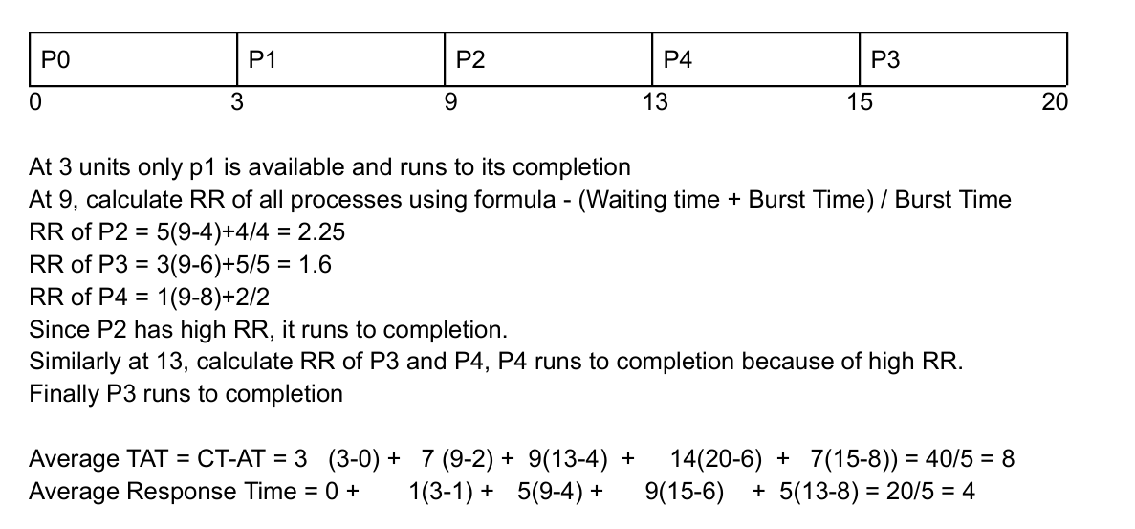

Q5. For the given basic node and list structure and assuming proper initialization, write a correct implementation for concurrent linked list insertion and lookup operation. [4m]
typedef struct __node_t { int key; struct __node_t *next; } node_t;// node structure
typedef struct __list_t {node_t *head; pthread_mutex_t lock;}list_t;// list structure
// insert function // Lookup function
int List_Insert(list_t *L, int key) int List_Lookup(list_t *L, int key)
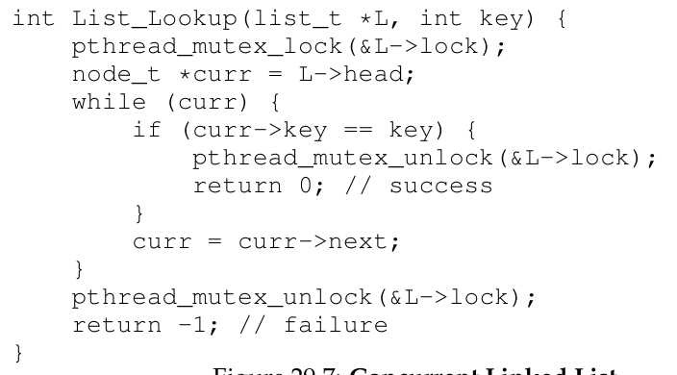
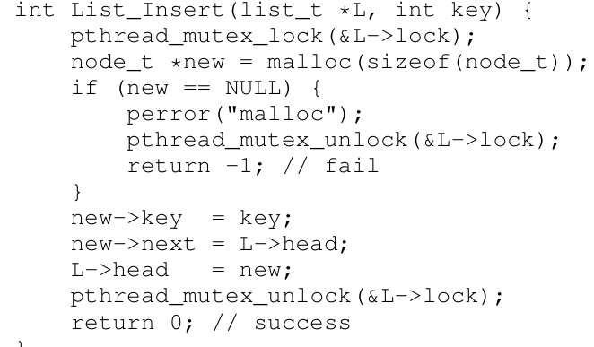

Q6. Suppose two threads execute the following C code concurrently, accessing shared variables a, b, and c. If both threads execute one after other, two possible values of c would be 4 & 13.
int a = 4; int b = 0; int c = 0; // Initialization
//Thread1  if (a < 0) { c = b - a; }  else { c = b + a; } | //Thread 2  b = 10;  a = -3;
What are the other possible values for c after both threads complete, if there is an interleaving in between? You can assume that reads and writes of the variables are atomic, and that the order of statements within each thread is preserved in the code generated by the C compiler. For each value derived, state the instruction interleaving order too. [3m]

Ans: c = 7 -> if switching happens immediately after if condition is evaluated and T2 runs fully and back to T1
c = 14 -> If T2 runs first and switching happened after b=10 is executed
c = -3 -> this is possible if T1 runs and goes into else part where it reads value of b but before it reads a, switching happens and then T2 runs fully and return back. Then value of a read will be -3 .

Q7. With respect to use of Condition Variable (CV), note that in addition to the CV, the wait() call takes a mutex lock as its second argument. State the dynamics of wait( ) call and explain the reason behind involving mutex lock in this design. Also briefly state the need for using a while() loop for the predicate check in the calling of the wait() operation. [3m]
Ans: The wait() on CV, puts the caller to sleep + releases the lock (atomically), otherwise how could another thread acquire the lock and change the state and/or signal it to wake up? Also if putting to sleep + releases the lock both is not done atomically then also there is a race condition so that is also taken care by this call. Before returning after being woken up, wait() re-acquires the lock, thus ensuring that anytime the waiting thread is running between the lock acquired at the beginning of the wait sequence and the lock release at the end, it holds the lock. This design of wait() call thus is very convenient for application use so that programmer need not worry about concurrency issues coming up.
When a condition variable is signaled to wake up a thread, it is removed from the wait queue but before that thread reacquires the mutex, another thread may be given CPU time (and potentially the mutex). As a result, the shared state may be updated before the waking up thread reacquires the mutex. Therefore, the thread must do another check when it actually acquires the mutex to ensure the condition it needs to proceed is still true.

Q8. Consider an application that has K + 1 threads running on a Linux-like OS (K > 1). The first K threads of an application execute a certain task T1, and the remaining one thread executes task T2. The application logic requires that task T1 is executed N > 1 times, followed by task T2 to be executed once, and this cycle of N executions of T1 followed by one execution of T2 continue indefinitely. All K threads should be able to participate in the N executions of task T1, even though it is not required to ensure perfect fairness amongst the threads. Assume threads share a counter count (initialized to 0), a mutex variable m, and two condition variables t1_cv, and t2_cv to be used for blocking threads wanting to do task T1 and T2 respectively. Fill in the blanks shown in the below skeleton code with appropriate statements ONLY (no comments) for correct working.
//function run by K threads of task T1  while (1) {  lock(&m);  1._while (count ==N)________  2.___wait(&t1_cv,&m);____________  unlock(&m);  //.. do task T1 once ..  lock(&m);  count++;  3.__if (count ==N)_________________  4.____signal(&t2_cv);______________  unlock(&m); } | //function run by thread of task T2  while (1) {  lock(&m);  5._while (count <N)__________________  6.______wait(&t2_cv,&m);_____________  unlock(&m);  //.. do task T2 once ..  lock(&m);  7.__count =0;______________________  8.__signal_broadcast(&t1_cv);___________  unlock(&m); }
In the next page, write very brief comment (along with the number) for each of the statements you filled in the above blanks to explain the working. [4m]

